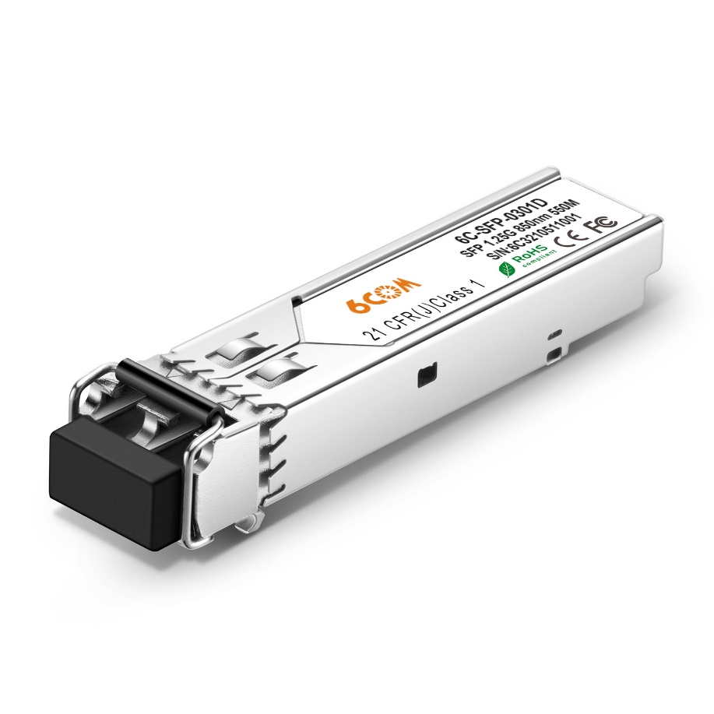
1000BASE-SX SFP 850nm 550m DDM MMF Transceiver
P/N: 6C-SFP-0301D

Features
- Data-rate of 1.25Gbps operation
- 850nm VCSEL laser and PIN photodetector
- Compliant with SFP MSA and SFF-8472 with duplex LC receptacle
- Digital Diagnostic Monitoring: Internal Calibration or External Calibration
- 500m transmission with 50/125µm MMF
- 300m transmission with 62.5/125µm MMF
- Compatible with RoHS
- +3.3V single power supply
- Operating case temperature: Standard: 0 to +70°C Extended: -40 to +85°C

Application
- Gigabit Ethernet
- Fiber Channel
- Switch to Switch interface
- Switched backplane applications
- Router/Server interface
- Other optical transmission systems

- Absolute Maximum Ratings
Parameter | Symbol | Min | Max | Unit
Supply Voltage | Vcc | -0.5 | 4.5 | V
Storage Temperature | Ts | -40 | +85 | °C
Operating Humidity | - | 5 | 85 | %

- Optical and Electrical Characteristics
Parameter |  | Symbol | Min | Typical | Max | Unit | Notes
Transmitter
Centre Wavelength |  | λc | 830 | 850 | 860 | nm
Spectral Width (RMS) |  | ∆λ |  |  | 0.85 | nm
Average Output Power |  | Pout | -9.5 |  | -3 | dBm | 1
Extinction Ratio |  | ER | 9 |  |  | dB
Optical Rise/Fall Time (20%~80%) |  | tr/tf |  |  | 0.26 | ns
Data Input Swing Differential |  | VIN | 400 |  | 1800 | mV | 2
Input Differential Impedance |  | ZIN | 90 | 100 | 110 | Ω
TX Disable | Disable |  | 2.0 |  | Vcc | V
TX Disable | Enable |  | 0 |  | 0.8 | V
TX Fault | Fault |  | 2.0 |  | Vcc | V
TX Fault | Normal |  | 0 |  | 0.8 | V
Receiver
Centre Wavelength |  | λc | 770 |  | 860 | nm
Receiver Sensitivity |  |  |  |  | -18 | dBm | 3
Receiver Overload |  |  | -3 |  |  | dBm | 3
LOS De-Assert |  | LOSD |  |  | -20 | dBm
LOS Assert |  | LOSA | -30 |  |  | dBm
LOS Hysteresis |  |  | 1 |  | 4 | dB
Data Output Swing Differential |  | Vout | 400 |  | 1800 | mV | 4
LOS |  | High | 2.0 |  | Vcc | V
 |  | Low |  |  | 0.8 | V

Notes:
1. The optical power is launched into MMF.
2. PECL input, internally AC-coupled and terminated.
3. Measured with a PRBS 27-1 test pattern @1250Mbps, BER ≤1×10-12.
4. Internally AC-coupled.

- Timing and Electrical
Parameter | Symbol | Min | Typical | Max | Unit
Tx Disable Negate Time | t_on |  |  | 1 | ms
Tx Disable Assert Time | t_off |  |  | 10 | µs
Time To Initialize, including Reset of Tx Fault | t_init |  |  | 300 | ms
Tx Fault Assert Time | t_fault |  |  | 100 | µs
Tx Disable To Reset | t_reset | 10 |  |  | µs
LOS Assert Time | t_loss_on |  |  | 100 | µs
LOS De-assert Time | t_loss_off |  |  | 100 | µs
Serial ID Clock Rate | f_serial_clock |  |  | 400 | KHz
MOD_DEF (0:2)-High | VH | 2 |  | Vcc | V
MOD_DEF (0:2)-Low | VL |  |  | 0.8 | V

- Pin Definitions

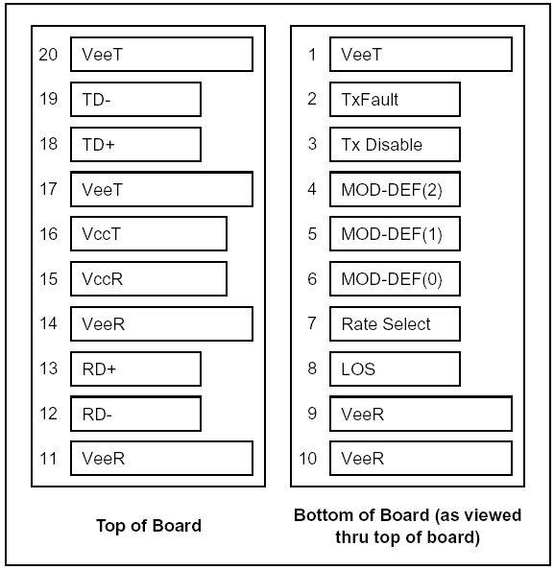

- Pin Descriptions
Pin | Signal Name | Description | Plug Seq. | Notes
1 | V_{EET} | Transmitter Ground | 1
2 | TX FAULT | Transmitter Fault Indication | 3 | Note 1
3 | TX DISABLE | Transmitter Disable | 3 | Note 2
4 | MOD_DEF(2) | SDA Serial Data Signal | 3 | Note 3
5 | MOD_DEF(1) | SCL Serial Clock Signal | 3 | Note 3
6 | MOD_DEF(0) | TTL Low | 3 | Note 3
7 | Rate Select | Not Connected | 3
8 | LOS | Loss of Signal | 3 | Note 4
9 | V_{EER} | Receiver ground | 1
10 | V_{EER} | Receiver ground | 1
11 | V_{EER} | Receiver ground | 1
12 | RD- | Inv. Received Data Out | 3 | Note 5
13 | RD+ | Received Data Out | 3 | Note 5
14 | V_{EER} | Receiver ground | 1
15 | V_{CCR} | Receiver Power Supply | 2
16 | V_{CCT} | Transmitter Power Supply | 2
17 | V_{EET} | Transmitter Ground | 1
18 | TD+ | Transmit Data In | 3 | Note 6
19 | TD- | Inv. Transmit Data In | 3 | Note 6
20 | V_{EET} | Transmitter Ground | 1

Notes:
Plug Seq.: Pin engagement sequence during hot plugging.
1. TX Fault is an open collector output, which should be pulled up with a 4.7k~10kΩ resistor on the host board to a voltage between 2.0V and Vcc+0.3V. Logic 0 indicates normal operation; Logic 1 indicates a laser fault of some kind. In the low state, the output will be pulled to less than 0.8V.
2. TX Disable is an input that is used to shut down the transmitter optical output. It is pulled up within the module with a 4.7k~10kΩ resistor. Its states are:
Low (0 to 0.8V): Transmitter on
(>0.8V, < 2.0V): Undefined
High (2.0 to 3.465V): Transmitter Disabled
Open: Transmitter Disabled
3. Mod-Def 0,1,2. These are the module definition pins. They should be pulled up with a 4.7k~10kΩ resistor on the host board. The pull-up voltage shall be VccT or VccR.
Mod-Def 0 is grounded by the module to indicate that the module is present
Mod-Def 1 is the clock line of two wire serial interface for serial ID
Mod-Def 2 is the data line of two wire serial interface for serial ID
4. LOS is an open collector output, which should be pulled up with a 4.7k~10kΩ resistor. Pull up voltage between 2.0V and Vcc+0.3V. Logic 1 indicates loss of signal; Logic 0 indicates normal operation. In the low state, the output will be pulled to less than 0.8V.
5. RD-/+: These are the differential receiver outputs. They are internally AC-coupled 100 differential lines which should be terminated with 100Ω (differential) at the user SERDES.
6. TD-/+: These are the differential transmitter inputs. They are internally AC-coupled, differential lines with 100Ω differential termination inside the module.

- Ordering information
Part Number | Product Description
6C-SFP-0301D | SFP, 1.25Gb/s, 850nm, MMF, 550m, DDM, LC connector, 0 to 70°C
6C-SFP-0301ID | SFP, 1.25Gb/s, 850nm, MMF, 550m, DDM, LC connector, -40°C to 85°C

